Caroline and Nayan’s Autumn Wedding at Dignita Hoftuin Amsterdam, NL

Who are getting married? Nayan and Caroline's chic, cozy and warm autumn wedding plans were underpinned by a mutual love of travel, shared sense of adventure and fashion. The mature but young at heart couple are cut from the same cloth. Originating from Manchester but residing in Amsterdam the couples' goal was to have an alternative mixed race marriage service. Read on...

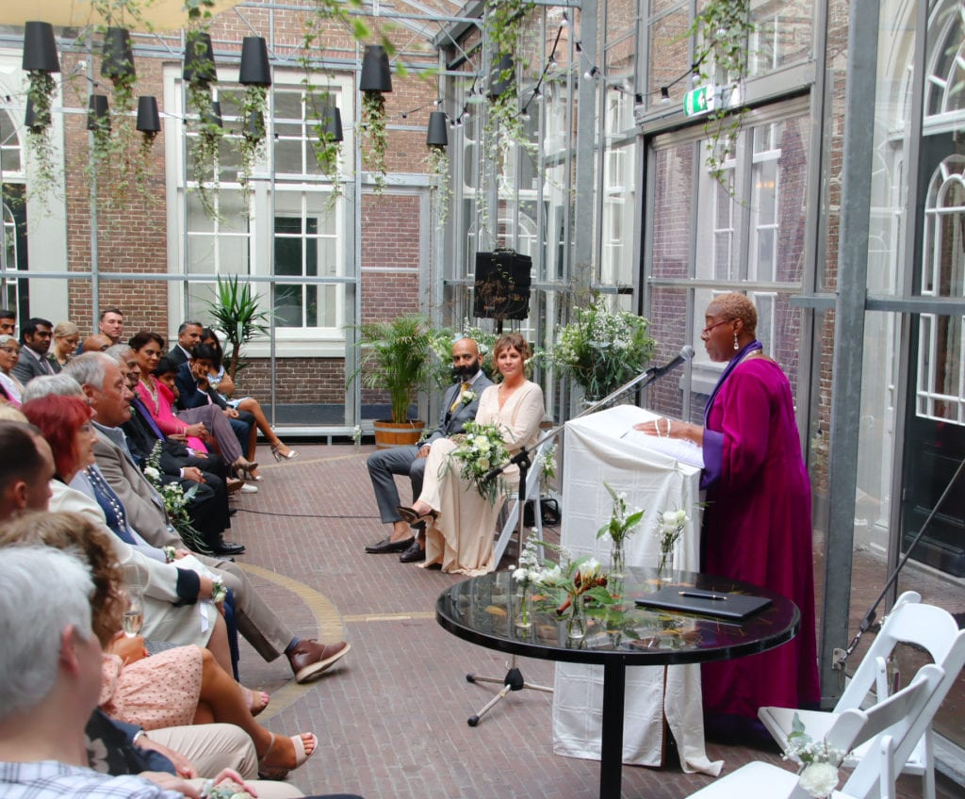 Autumn wedding ceremonies abroad: cosy, elegant and warm fall wedding in a green house Dignita Amsterdam - image burgundyproductions.nl

What brought the couple together? Why did they have an elegant autumn wedding? Of course, there is always a common denominator. And that is Nayan and Caroline's shared ethical beliefs, joint interest in travel and mutual love of spending quality time with family and friends.

Where was the second wedding hosted? Well, the pair wanted a lively autumn wedding celebration that fused Hindu and British marriage cultures and traditions. Later, they planned a big fat Hindu wedding in Nayan's country of origin, India. So, be inspired by their cross-cultural fusion wedding ceremony. Perhaps you'll want to create your own. Keep reading...

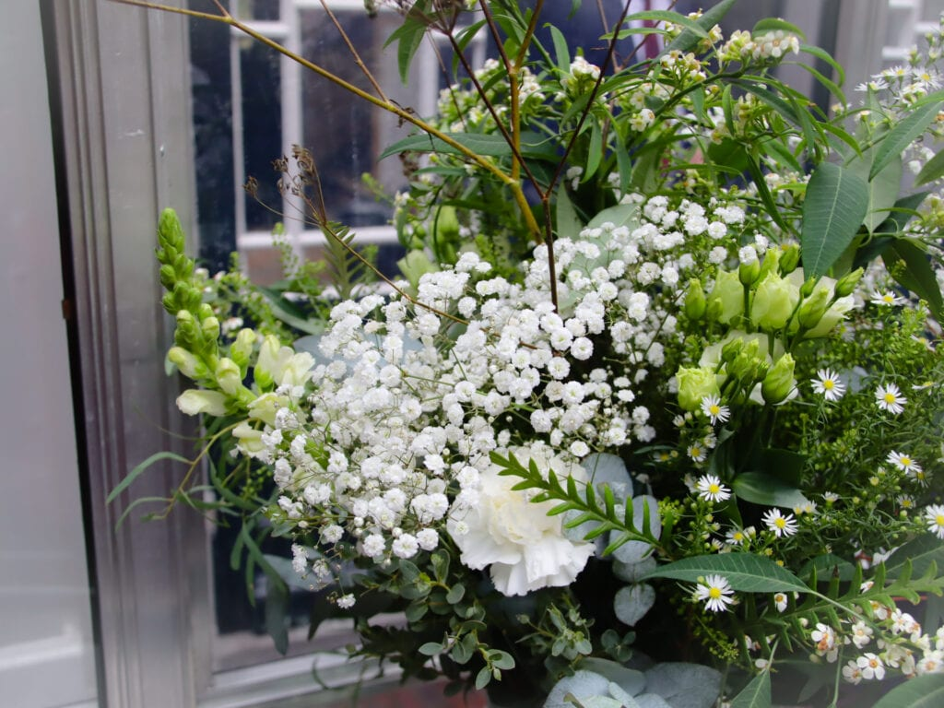

Autumn weddings for happy couples

Happy bridal couple: Nayan and Caroline

Venue: Dignita Hoftuin De kas - greenhouse | Nieuwe Herengracht Amsterdam, Netherlands

Date: 28th September 2019

The Proposal
Mr & Mrs WP's lives had crossed three times, once in Britain and twice in Holland. And the chance meetings finally led to twelve years of relationship bliss. When did Nayan pop the question? Well, it was on their love trip to India and Caroline said YES, at one of the seven wonders of the world. The UNESCO world heritage site Taj Mahal.

The Venue
Caroline came down the aisle and Nayan didn’t take his eyes off her. Positioned in front of the altar, we warmly welcomed the blushing bride and handsome groom. And guest were greeted with "Namaste". It was a touching and serene moment. Nestled in an idyllic garden the venue complimented the glorious sunny autumn day. In fact, the greenhouse was filled with the perfume of the beautiful couple's chosen bridal flowers. It oozed peace.
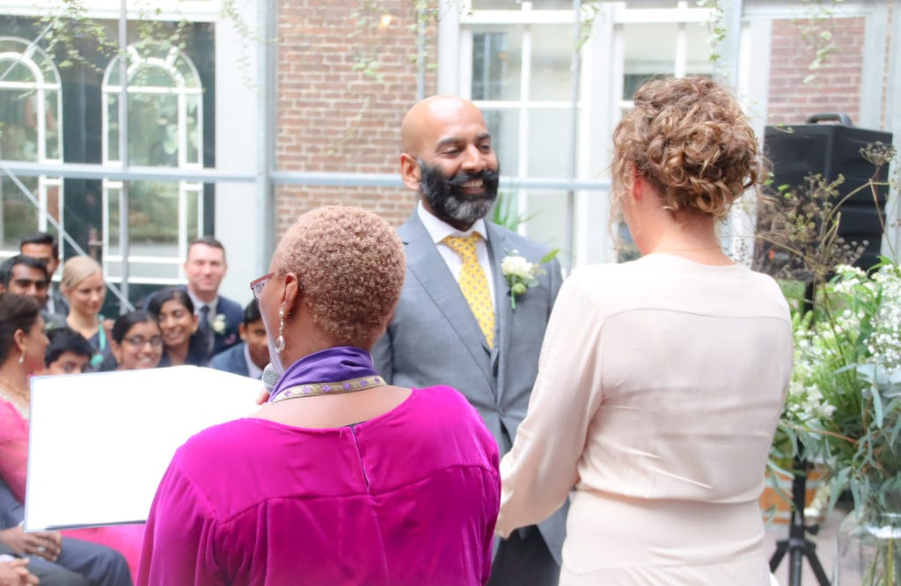 JoThornhill Photography

Consultation - Autumn weddings
But are you wondering where they found me? Well, read this:

Hi There Clover!
We found you via The Celebrant Directory and would love to speak to you about your services for fall and winter weddings! I hope you have all the details necessary to get in touch! Thanks, and hope to speak to you soon!

Planning - Botanical weddings
Writing the marriage service script was pure pleasure. We incorporated all important family members and revised many drafts to get it right. Nayan and Caroline spilled the beans on their love life and guided me down a romantic memory lane. Of course, the couple didn't share all the juicy bits, just enough to create a lively ceremony and deliver a cracking wedding speech.

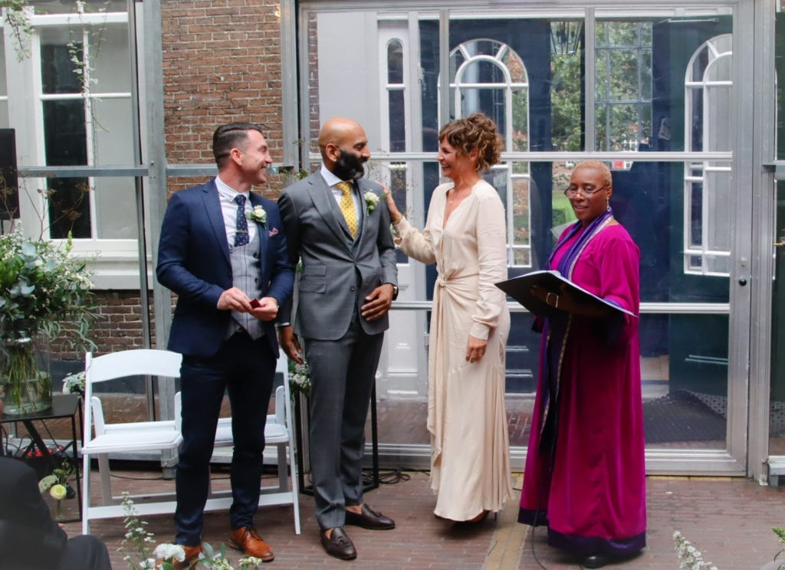 The best man delivers the precious rings to the altar at a garden wedding in Amsterdam

Inspiration - Greenhouse Autumn weddings
The greenhouse wedding ceremony with see-through glass walls and ceilings was perfect. Under the enticing autumn afternoon sun of the Dutch conservatory, family and friends witnessed the beaming couple make promises of undying love, loyalty and commitment.

The kiss and swapping of vows
The beaming couple choose not to swap promises of love but opted for the "official" wedding vows. It read: To have and to hold from this day forward, etc. Then, the ultimate moment of the ceremony arrived, Nayan looked besotted when I said, “You may now kiss each other.” The congregation cheered and clapped, as the happy couple shared a kiss while warmly embracing each other.

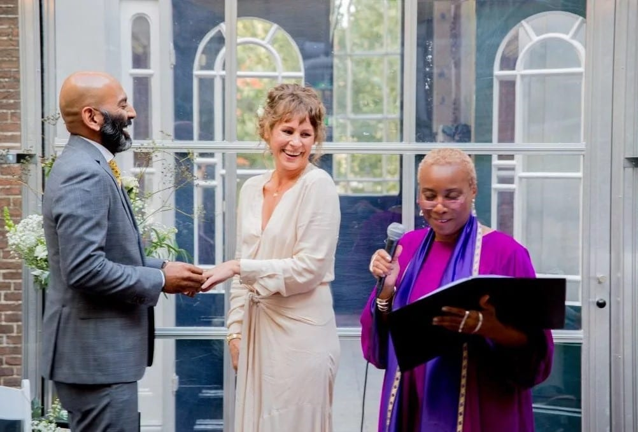 Autumn wedding ceremonies - it's time for the groom to kiss the bride!

Unique wedding symbolism
The groom and bride exchanged rings, kissed, and completed the wedding ceremony with the signing of a symbolic marriage certificate. Nayan sealed the deal and confirmed their commitment to each other by hitting the ceremonial hammer on a wooden block. Smiles of joy and happiness filled the ceremony room and cheered.

Final wedding ceremony act
Lastly, Caroline and Nayan invited family and friends to affirm that they would help them find middle ground and fall in love, time and time again with each other. Guests responded with “We will” and cries of laughter, joy and non-stop tears.

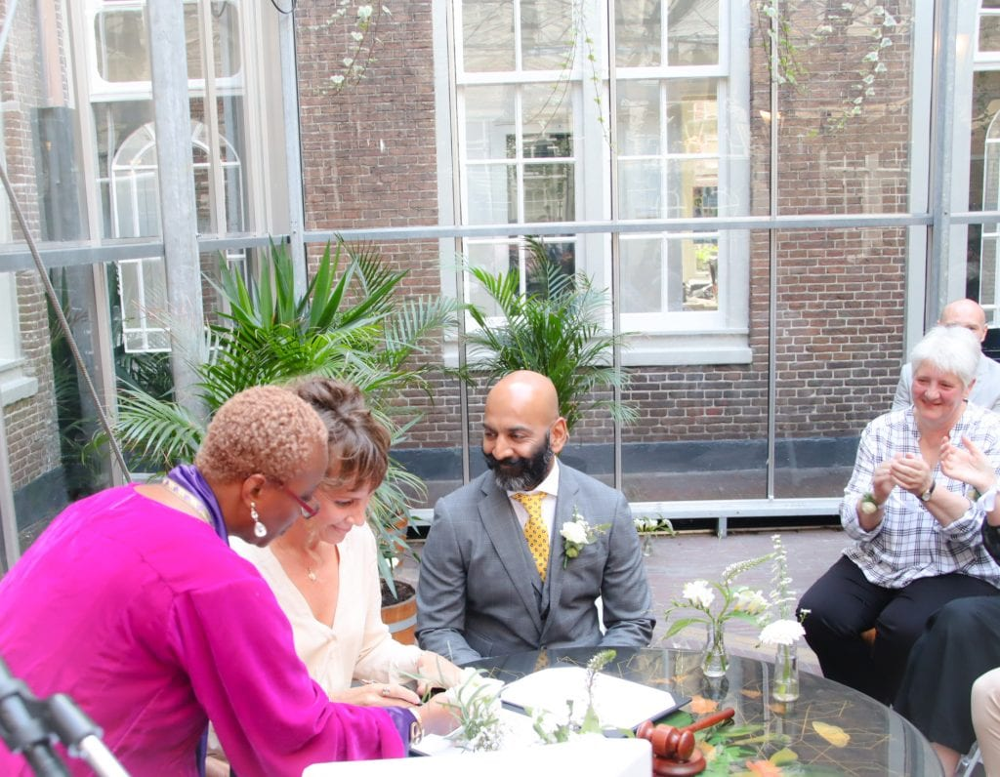 Beaming groom looking adoringly at the blushing bride - signing symbolic wedding certificate!

Autumn wedding ceremony songs
Welcome music: Yellow Brick Cinema – Relaxing
Bride's processional: United guitar players - Here Comes the Sun
Marriage certificate signing song: Yellow Brick Cinema – Relaxing
Recessional: Jasmine Thompson - No place I’d rather be
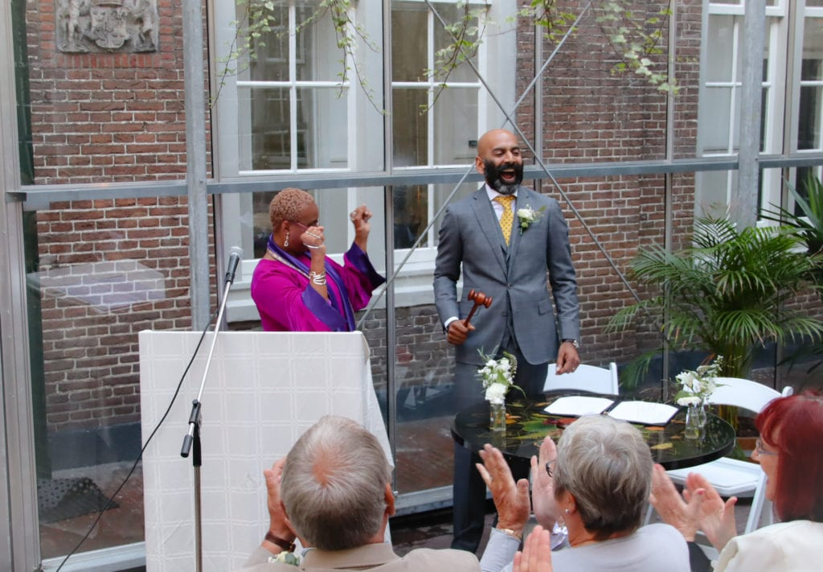 The beginning of a married life and a wonderful closure to a special wedding day!

Autumn weddings - outfits
Stunning bride's attire: No veil, just a single white flower in Caroline's hair. Dress by www.jacquemus.com 2018 collection…… | comfortable wedding shoes by bride
Dapper groom's attire: Smart grey suit and accompanying yellow tie with white flower in buttonhole.

Autumn weddings - suppliers & vendors
Venue – Dignita Hoftuin - De Kas [greenhouse]
Caterers – own caterers & eatwelldogood.nl
Wedding photographer – Jothornhill photography & burgundyproductions.nl
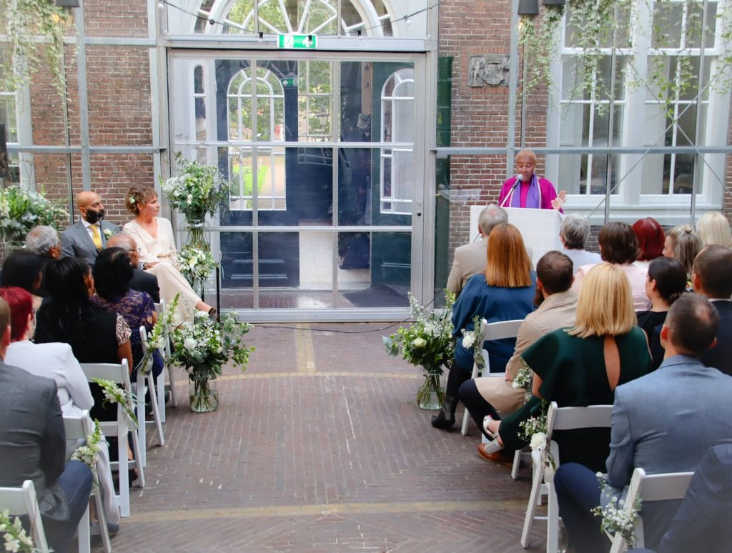 Autumn wedding ceremonies by Clover Jean Celebrant relaxed, funny, compassionate, entertaining yet serious where needed. www.cloverjean.com

Autumn wedding ceremonies couple's - feedback
Dear Clover,
What can we say?! You made our day and set the tone perfectly for our whole day, we couldn’t have asked for more, it was totally perfect!
Every single one of our guests said you were fantastic, and it was the best fall wedding they had ever been too. We can’t thank you enough!
Thanks
Mr & Mrs. WP

